RFP No. 744-R1918 – Legacy System Support (“RFP”)

ADDENDUM 2

DATE: June 05, 2019

TO: Prospective Proposers

The following are University’s responses to bidder’s submitted question and additional information

This Addendum 2 shall herein be made part of the RFP.

- What is the ticketing system used by UTHealth?
HEAT
- Can you estimate what percentage of incidents are not documented? i.e., email, phone, in-person support not logged in the ticketing system.
All calls/emails are to be documented so this should be nominal
- To what extent are current support processes documented?
We have general processes documented.
- Please confirm that the help desk (i.e., Tier 1 support) remains the responsibility of UTHealth and not the vendor.
The actual help desk is UT supported, any basic tickets (password reset, desktop, is UT responsibility. Support of end users for system questions related to EHR or Clinical Technology related items would be the responsibility of the vendor staff.
- What is the current number of open requests and the average number of days open?
Allscripts Touchworks:For 90 days there were 2159 Ticket created for the Allscripts application. The tickets are open an average of 12 hours. Sunrise help desk calls occur at a rate of approximately 1-2 a day. 99% resolved same day
- Does UTHealth use application monitoring tools to monitor and report on application health and performance?
Our Data Center team is responsible for managing/monitoring performance
- Can you provide the current staffing levels and organization chart for application support, including reporting and interface support, middleware and device support?
See the below org charge for the Allscripts EHR team that supports the Allscripts and LVM (Nurse Triage) application end user support and training. LVM training is done by the Nurse Triage team.
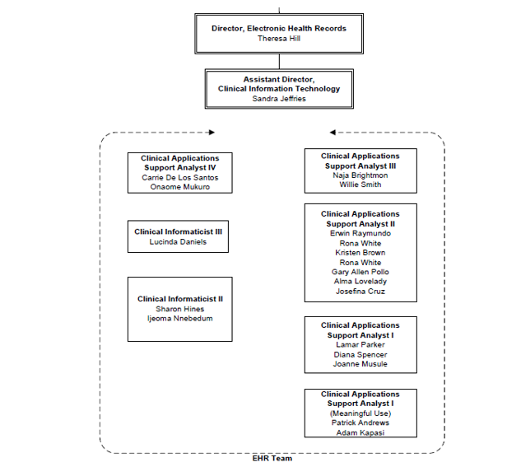
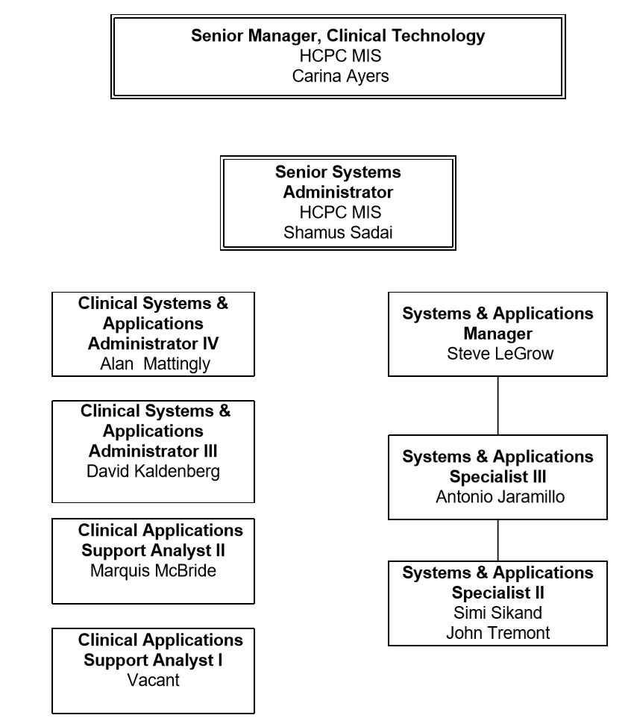
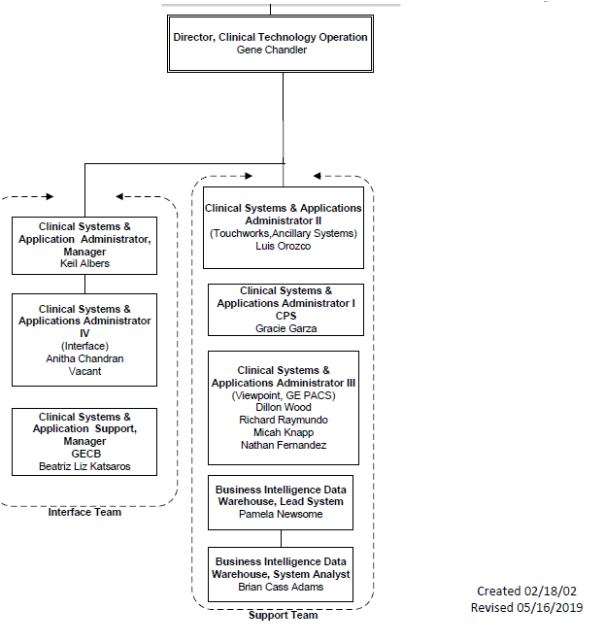
For Sunrise: HCPC:
- Cerner Invision support including PA/PM/Reporting: 1 FTE
- Sunrise application support 1.5 FTE (Reporting within Sunrise is supported by contract with Allscripts)
- Cloverleaf interface support 1 FTE
- Operational Reporting (From Sunrise) .25 FTE
- Does UTHealth currently use 3rd party resources to provide any of their application support? Only for Invision and GE Centricity Business
- How many of the in-scope applications does a current staff member typically support on average? One to many depends on role
- Does UTHealth intend for any current staff to remain dedicated to in-scope application support? Some may choose to stay who are not intending to stay at UT beyond Epic rollout in lieu of participation on Epic
- Please describe UTHealth’s current Change Management Process.
Departmental system and UT health system
- If vendor is replacing a staff member who represents support items to UTHealth’s Change Advisory Committee, would the vendor be expected to take on that role?
Yes
- Is there an existing support Service Level Agreement (SLA) for UTHealth’s portfolio of applications and third-party modules and applications? Can you provide the current actual service levels?
Best effort (internal)
- Is there a desired SLA for the RFP, both within business hours and on-call support required outside business hours (09:00-17:00)?
Yes, please propose other than best effort
- Please describe the current 24/7 on-call Helpdesk process and how it’s configured. Allscripts/ECW/CPS On call cell phone outside of primary help desk hours 7-11 MF 7-5 S/S HCPC has an on call pager that staff rotate for one week approximately every 8 weeks for calls after 5pm, on weekends and full closure holidays. We have a very well defined policy that restricts calling this pager to only true patient care function emergencies resulting in a very low call volume of ~1 call every 3 weeks
- What are the on-site expectations for the contractors?
Direct client support roles are on-site
- What is the general ratio of support vs. projects for the in-scope applications? Is it expected that upgrades and enhancements will be reduced over the project term? Do you have any planned upgrades or enhancements for the in-scope applications?
Nothing planned at this time, and updates/changes will be reduced to break fix and regulatory requirements
- Please confirm that all hardware, network, storage, other infrastructure equipment and hosting will be supported by UTHealth.
Yes, we will manage these components
- Will UTHealth be responsible for the test environments for the testing and validation associated with application updates/upgrades, application configuration changes, server patching, domain refreshes or infrastructure changes?
UTHealth expects to limit changes/patching and will work with chosen vendor(s) to test implement changes. But vendor should be responsible for efforts.
- Can UTHealth share an interface diagram showing inbound and outbound interfaces across legacy systems?
Yes, interface diagram is herein attached
- Often ancillary applications have super users or dedicated support staff to address more simple tasks. Is any IT support provided by department resources (e.g., for Radiology, Pharmacy)?
Yes, Radiology
- Is the vendor expected to support end user provisioning/security access/password resets, etc. for UTHealth staff across all applications?
Provisioning yes, the rest no
- Will the vendor be responsible for the decommissioning of legacy systems upon successful migration to Epic?
No
- To what degree are the analysts also responsible for supporting end user computing devices associated with their assigned application(s) (e.g., bar code printers, scanners, device mapping, specimen labels, forms labels, etc.)?
Nominal, we have a dedicated desktop team that will be point for devices.
- Please list any known upcoming projects or regulatory requirements that will impact these applications.
None at this time
- Are all in-scope legacy applications covered by an up to date vendor maintenance agreement? If not, please identify which are not covered.
Yes
- If multiple vendors are selected to provide legacy system support, how will those vendors be managed? Would UTHealth manage the vendors, or would a primary vendor be chosen to manage the other vendors?
UT Health is most likely option
- To what extent would the chosen vendor be interacting with the in-scope application vendors? Depends, if issues reported need vendor assistance to resolve, the expectation is for the staff would be asked to work to resolve.
- Page 6, 1.3: Is UTH’s Epic Implementation currently on schedule to start on Sept. 1, 2019?
Yes

- Page 19, 5.4.1: Are consultants in the ‘Reporting/BI Analysts’ role expected to provide custom report writing support? If so, what number of requests are expected and what is the average development time per report?
Lights on approach, potential is for any changes to existing reports/dashboards and regulatory required reporting.
- Page 20, 5.4.1.1: In providing a “current client list”, should this be limited to just clients for whom the vendor has provided legacy support?
Can be more, but this is required
- Page 20, 5.4.1.1: In providing “detailed analysis of similar client’s performance pre and post transition to proposed solution”, what specifics about performance should we provide?
Relevant tracking KPI’s esp issue response and closure times, customer satisfaction, etc
- Page 20, 5.4.1.2: Can you please describe UTHealth’s requirements, if any, for support of interfaces and data mapping to/from Epic?
Optional item – please propose if able
- Page 20, 5.4.1.2: Can you please describe UTHealth’s requirements, if any, for support of data conversions to Epic?
Optional item – please propose if able
- Page 35, Section 4: There is a form that references RFP No.: 744-1917 EHR/RCM Partner. Should we assume this should read “RFP No.: 744-1918 Legacy System Support” and complete as instructed?
This is a typo. Yes, it should read RFP No.: 744-1918 Legacy System Support
- Page 34, 3.6.3: Please explain why vendors might need to use a contingency plan or disaster recovery (DR) plan during this engagement? Does UTHealth want vendors to supply a disaster recovery plan that replaces UTHealth’s DR plan for supported applications?
We conduct annual DR tests and expect vendor to continue such. No
- Page 41: Please confirm that the Certificate of Interested Parties Form (1295) does not have to be completed and submitted until the proposer is selected and an agreement is signed between the proposer and UTH.
Confirm; that is correct.
- Page 34, 3.2.4: Can you please describe the types of reports, and the frequency, required during this engagement?
Please propose
- Can you elaborate more on what conversion services/needs you are seeking and how are they to be priced? Are you expecting the legacy support resources to have that knowledge of Epic? Optional item – please propose if able

- What are the required/desired support hours for each of these applications? e.g. 7x24, 8-5 M-F, etc.

  - Primary support M-F 7-7, afterhours support (cell/tickets) the rest

- What are the expectations related to after-hours support?
Generally limited to Sunrise and Invision, our ambulatory practice has nominal support needs after 7pm.

- How many FTEs are currently supporting each of these applications currently? Do you anticipate these needs to change, and if so, how?
Less than current as limiting changes

- The proposal calls for company experience like in section 5.4.1.1 and 5.4.1.2. Will the subcontractors’ capability and experience also count towards this credit?
Yes

- Can you share the details of the legacy system maintenance support tasks and the total effort that has been performed in the past year?
For Allscripts, the only routine maintenance task is watching the Print Queue for failures.
For the LVM (Nurse Triage) system, there are monthly updates to the proprietary protocols guideline data.
For Sunrise/Invision Last upgrade 6/2/2018 to 17.3 CU4
All other tasks have been regular day to day support tasks totaling 337 in the last year for Sunrise, Invision and all other miscellaneous help requests combined. (<1 per day)
MIS Service Request tasks include Merge requests in Invision, Account requests (~1800/year), adding/adjusting medications in Sunrise (~40/year), Changes to Notes/Orders/Security rights due to business process updates (~1-2/week) Technical system monitoring also include the following:

  - CPS- User creation, location add’s, providers, patient merges, daily errors, charge corrections if ICD 9 codes are chosen. 4-5 hours daily max
  - eclinicalWorks-User creation, Occasional troubleshooting of client issues, tickets -1 hour daily max
  - Allscripts- (Lab, Results, MHHS Documents) Errors, 30-35 hours weekly

- Will UTHSC-H manage the delivery (time and quality) and total budget of each assignments/ task or would vendor manage these? Is there a preference?
This should be a collaborative effort

- Can you provide ticket data from Heat, or other, for the applications listed in Section 5.2 of the RFP as requiring support? 3-6 months is ideal if possible.
See answer above

- Could you tell us the number of staff currently providing support for the applications referenced in section 5.2?
See answer above

- Do you require a dedicated staff augmentation model for legacy support or would you consider a remote, legacy support as a service model?
Prefer onsite but would consider all options presented with the exception of offshoring

- What hours of support do you require? 24x7, 12x5, etc.
See answer above

- Can you provide any SLAs (service level agreements) in place for support of legacy applications if you have them?
See answer above

- In section “2.3 Criteria for Selection” of the RFP, it is detailed that the criteria being evaluated are Company Experience/Competency and Cost. Could you describe how each will be weighted in your decision for selecting a vendor?
We do not disclose criteria weights

- Can you describe the expected UT Health FTE transition to Epic team? Is the entire team expected to move to Epic?
We expect the majority, exact number unknown

- Can you provide details regarding current ticket volume? A report that includes ticket creation time, priority, status, and time taken to complete would be helpful. Ticket details that include PHI can be omitted.
See above answer

- Does UT Health currently utilize a primary (tier 1) support desk for tasks equivalent to password resets (LDAP, etc.). If so, will this be maintained or considered in scope for this RFP?
Yes we do and no we are not looking for services for this.

- We would like better clarity into UT Health’s vision for “keep the lights on” support. Will the following be considered in scope for this project?
  - Major system upgrades – not expected
  - Cumulative updates / patches – only if needed for regulatory reasons
  - In-flight projects (integration, etc.) only if needed for acquisitions or regulatory
  - Projects required by government programs or other 3rd parties - yes

56) Will new user training be considered in scope at any point of the engagement and can you describe the expected scope considering impact to clinical operations (Providers, MAs, front desk)?
For Allscripts Training will be in scope. This includes Providers (video combined with 1 hours classroom), Clinical Staff is 2 full days, Clerical for billing staff is 1 day and then one hour classes for MDCharge and Prenatal. We do have a video for View only access and Medical Students. You will be responsible for training the 350+ Residents in June of every year.

57) We expect a majority of the support can be conducted remotely, however will there be any constraints with UT Health providing onsite staff with physical office space?
No constraint

58) Can UT Health provide the infrastructure to accommodate remote support - virtual desktops, phone system routing, end-user desktop sharing, etc.?
We have the ability to accommodate VPN access and desktops. Phone routing is supported on our current telecommunication platform as well as remote desktop support.

59) During the phone call there was a correction identified to the prospective start date from 7/1/2019 to 9/1/2019. Is the September timeframe when current UT Health FTEs begin Epic training or when knowledge transfer will begin?
When UTHealth FTEs begin training, knowledge transfer and onboarding needs to happen before that date likely not before 9/1/19.

60) Is UT Health willing to share current job descriptions for the teams that will be transitioning to Epic? We are mostly interested in noting skillsets as many of these project have had unexpected skills required – example, Allscripts analysts need to be trained on SQL database queries.
Yes

61) What is the current management process for these resources? Currently, how many of each role do you have? (Allscripts touchworks analyst, GE centricity practice analyst.. etc. ) See answer above

62) Section 5.4.1 Staff Augmentation for Support of Legacy Applications states “Staff in these roles are generally expected to be on-site; however, remote work may be possible dependent on project tasks.”
    - What are the onsite expectations for the following roles?
    - Program Manager occasional onsite
    - Analysts customer facing roles are onsite

63) Are you able to provide the number of FTE’s supporting the in-scope applications today?
See answer above
  - Will any FTE’s stay on the Legacy Support project? If so, which applications would they support, and at what point in the project would they transition to the Epic implementation? See previous answer on transition of current staff

64) Will the awarded team have access to the existing Service Desk System and knowledge base? What tools are utilized today?
We use HEAT, and yes they would have access

65) If possible, please provide service desk metrics for your current support team such as:
  - How many calls are received weekly and monthly from your Service Desk application by module?
See previous answer
  - How many system changes are requested weekly and monthly?
See previous answer
66) At what point in the project will support of the legacy applications move to a ‘keep the lights on’ function?
As close to 9/1/19 as possible

67) Will the legacy support team be required to provide 24/7 on-call support? See previous answer
  - Is a rotation of on-call resources acceptable?
  - Is remote support acceptable for on-call rotation analysts?

68) Section 5.4.1.2 RFP Requirements references data conversion to Epic, strategies, and tools used. Will any of the Legacy Support resources be expected to participate in the data conversion process to Epic?
Assist in mapping out data/reporting/extracts where possible

69) Please provide a list of any ongoing or future projects planned for the in scope applications considered in scope with the following information
At this point in time, the Allscripts backfill team will be responsible for the 17.1 CU11 upgrade from 17.1 CU9. Start date would be 2/2020 with a go live of 4/2020. You will need 2 to 3 senior analysts and 7 to 8 junior Analysts. They will need to complete 10 hours a week to testing and/or configuration each. If there are any other regulatory updates that are required, the backfill team will be responsible for those changes. The Allscripts backfill team will be responsible for implementing Allscripts for clinics acquired as part of an acquisition.
HCPC Potential Effort:
- Establishment of HIE from Sunrise to Greater Houston HealthConnect. Sunrise analyst responsibilities include testing and validation only of work performed by contracted Allscripts consultants via separate contract.
Project started 5/2019, anticipated end date in ~1 year
- Upgrade Sunrise to 20.x version – requires at least 1 senior analyst, 1 junior analyst and 1 trainer to provide “Train the trainer” if needed
Project may be required in Fall/Winter 2020

  - Start date/End date
  - Proposed hours by application/position or required skill

70) What ITSM (IT Service Management) ticketing tool is currently in use to track break/fix incidents and requests?
HEAT

71) Do you anticipate that any of the in scope legacy applications will be rolled out to newly acquired practices/locations prior to the Epic go live? This may be included with the project list, but is important to understand impact on staffing needs.
Possible as we are a growing enterprise

72) Please provide a current headcount break down by position by application for the application list provided in the RFP to support managed service estimations. See previous answers
a. Please identify specific skills requirements by position. For example- GE Analsyt that has report development skills, or SQL query abilities.

73) Please provide the desired headcount by position by application for the applications list provided in the RFP to support pricing for staff augmentation. See previous answers
a. Please identify specific skills requirements by position. For example: GE Analyst that has report development skills, or SQL query abilities.

74) Please identify the positions and quantity of resources you feel must be on site full time to provide desired level of support. See previous answers
a. Please identify specific skills requirements by position. For example GE Analsyt that has report development skills, or SQL query abilities.

75) Please provide ticket volumes (break/fix incidents, service requests, requests for enhancement) for each of the in scope applications. See previous answers
  - Incidents by Application/Module broken down by priority. For example Critical, High, Med, Low. Include Average Time to Resolve if available.
  - Please also provide the number of after hour incidents by Application/Module
  - Service Request by Application/Module
  - Access Request by Application/Module

76) For the GE Centricity application, does your current support team include Cache/MUMPS programmers?
We subcontract that out currently with our GECB support so no.

77) The Addenda Checklist has the wrong RFP No. and name. Will a new one be issued or can we correct the information on the existing document?
Please correct the information on the existing document.
In Section 4 Addenda Checklist, the RFP no. is 744-1918 Legacy System Support

78) During the vendor conference you mentioned that you would be open to alternative pricing models. Would you prefer that we add a tab to the spreadsheet or an addendum?
You can add a tab for alternative pricing models. However, this is only optional and may not be evaluated.

In order for your proposal to be considered responsive to the RFP and evaluated, you must complete the required tabs of the spreadsheet also.

79) In Section 5.4.1.2 there appears to be a few questions that are related to Epic Implementation experience instead of Legacy Application Support. Specifically:
  - “Describe your experience supporting large Epic Implementations in complex academic organizations” – Do you mean from a legacy support perspective?
Yes from a legacy support perspective, assisting as we map out migration data
  - “What is the total number of Epic related engagement contracts you have been awarded over the last 5 years.” Is this related to Legacy support or both legacy support and implementation for Epic
Both if possible and delineated
  - “Must have qualified/certified (and preferably experienced) staff. Is this related to the legacy support applications?
Yes, people experienced/qualified in supporting our legacy applications

END OF ADDENDUM 2

